بسم الله الرحمن الرحيم



King Abdulaziz University - Faculty of Engineering – EE-499

**Senior Design Project**

**Report #1**

Project Charter

Team#3

Advisor: Dr.Muhammed Bilal

|  |  |  |
| --- | --- | --- |
| **No.** | **Member** | |
| **1** | Muhannad Saeed Alghamdi | F21_T03_M1_1846525 |
| **2** | Sulaiman Abdullah Abbas | F21_T03_M2_1845862 |
| **3** | Wael Rabah AlDhaheri | F21_T03_M3_1846987 |

Table of contents goes here

# Introduction

Engineers around the world follow many design principles and/or steps. In this report, which is the first assignment in our EE-499 senior design project, we will discuss the first part of our journey which is the project charter. To explain, a project charter is an important reference document which ensures the team manager understands the customer needs and requirements, provides vital information and acts as a common ground for everyone involved. In this report, we will discuss some background information, literature review and finally the project charter.

# Background information

First, to find out if there is a problem with document delivery on campus, we consulted with some of the administrators in the faculty and we learned that they do most of their administrative work is online. Although, some documents that need to be signed or stamped are sent physically to the deanship.

After that, we surveyed the campus. And we noticed a few things:

1. There are different terrains in the campus: streets, tiles, mud, grass, etc.
2. Often, there are students in the halls (roads?) between buildings
3. The buildings are wheel-chair accessible)

As shown in the figure, the distance between the faculty and the deanship of administration is approximately 240 meters

Figure 1 - Map of the region near the faculty of engineering

# Literature Review

As engineers, we are tasked to fully study a situation before engaging in any developmental and or design activities. Furthermore, to understand the current technology and innovation of our century we will conduct a literature review on three cases. Undoubtedly, these cases will cover autonomous robots and some of their uses. It should be noted that most of these cases are within the past few years. Which will give us an accurate lookout on the current technologies. On the other hand, we believe these cases might give us inspiration to lead us into some ideas for our problem solution.

## Case Study #1: Smart Drone Delivery System [1]

With the ever-growing usage of online shopping and e-markets, the usual petrol operated vehicles that succumb to gravity is not enough to cover the demand that is skyrocketing. Consequently, the first case study published by Shivaji University in India talks about a smart drone delivery system. In this delivery system, it is proposed that a Quadcopter (QC), which is an Unmanned Aerial Vehicle (UAV), delivers orders requested through online shops autonomously by the use of Google Maps and its own processing unit. The paper also mentions “the QCs capability of delivering parcel ordered by online and

coming back to the starting place.”.

The QC’s that will be deployed should have a vertical take-off and landing protocol in order to reduce the area required for functionality. Furthermore, this will allow the QC’s to function in small neighborhoods and streets which many cramped cities have. A 10–15-mile radius can be covered by a single QC. In addition, the vertical approach to these QC’s allows them to carry more payload, this in turn will yield better results for the online shops.

A basic working principle for the QC’s was stated in the paper. A total of four rotary motors at equidistance from each other and a central driver is suggested for a vertical takeoff/landing protocol. To be clear, this configuration functions in a specific way. As such, opposite rotaries spin in opposite directions while adjacent ones function similarly. Using this design, any gyroscopes controlling the QC’s is not needed.

Finally, the methodology for delivering the shipments is as follows; The processing unit of the QC’s, which is a raspberry pi, is interfaced with a camera, video streaming, SD card and GPS. When an order is placed, all these technologies work together to find the correct address of the house and deliver the shipment. Below is a figure that showcases the order of operations.

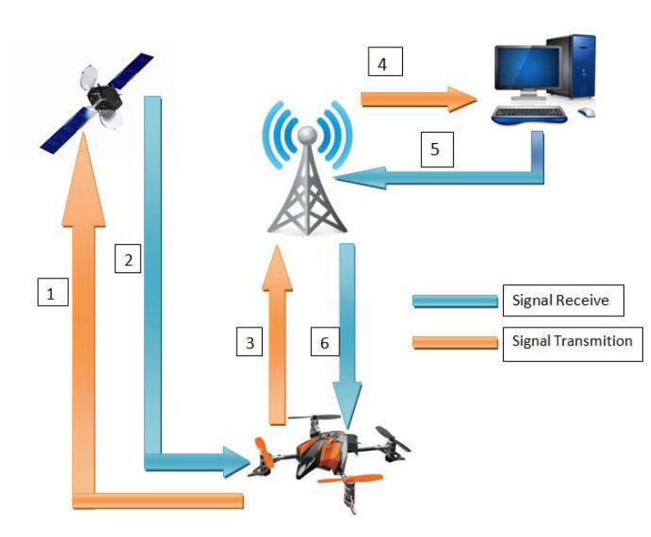

Figure 2 Showcases the order of operations the QC's follow

## Case Study #2: Prototype design of medical round supporting robot “Terapio” [2]

In this case study, the main focus is a robot that is implemented inside an important ecosystem. Terapio is a medical assistant autonomous robot that will revolutionize the healthcare scene. Its main functions are to deliver armamentarium and provide health care data to the doctor. Whether it be a scalpel, a syringe or even a dental kit, this robot can fetch and receive any equipment a doctor need. Furthermore, the robot has the medical history of the patient and can assist the doctor in evaluating a patient’s needs. The robot boasts an internal storage and object detection which can prove to be helpful in navigating the hospital hallways that are clustered with personnel and objects.

Fascinatingly, the robot has three main modes of operation. First, human tracking mode. The robot follows the specified doctor and accompanies him wherever he goes. This mode is useful for the doctor since he does not have to worry about carrying the robot around. Second, Power assisting mode is where the robot can hold the patient, hold a tool or even detect force specified by the doctor. To explain, a dentist might need a tool to be held in a specific way to access a wisdom tooth. The robot can hold the tool precisely and accurately. This in turn can reduce the burden on the dentist and allow him to complete the surgery effectively. Finally, the round mode is an interesting mode. The robot listens to the consultation and records it. Furthermore, the robot denotes everything and organizes it for the doctor for later use. An extra feature of the robot is its facial expressions. These facial expressions help reduce the emotionless of the robot which in turn can increase the healing of patients via emotions. Below is a figure representing the modes of Terapio

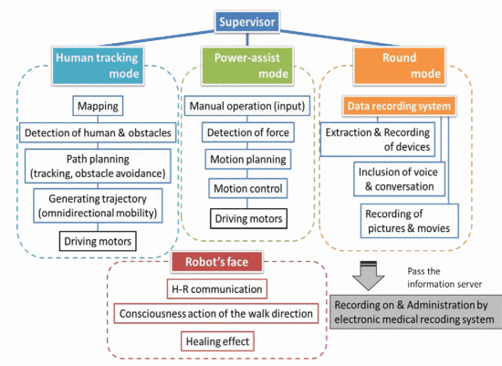

Figure 3 showcases Terapio's modes

## **Case Study#3:** Design and Development of Autonomous Delivery Robot [3]

This research published by Visvesvaraya National Institute of Technology discusses the design of an autonomous delivery robot with some limitations. This project is capable of carrying a maximum weight of 2kg this low-bar line is due to the use of low torque motors. To carry higher weights the use of higher torque motors is essential. On the other hand, the motors used have 300rpm which increases the ability of moving the robot much faster ensuring it is within the road speed limits. For the main board the project uses Nvidia Jetson TX1 for controlling and running global and local planning algorithms. It also uses an Arduino Mega to control the motors and manage the sensors' readings. The two boards communicate using rosserial to publish the sensors' readings and to receive the moving commands controlling the motors. The design uses multiple components to provide much accurate localization and obstacles avoidance, one main component used is a RGBD camera which is used to get the front view with 3D depth map with addition to a laser range finder which gives a 2D depth map. Another component used for an accurate localization of the robot and for the purpose of determining the orientation of the robot is the inertial measurement unit (IMU) which includes an accelerometer, a gyroscope and magnetometer for a better estimate of the position. To avoid collision, an IR sensor with a range of 4-30 cm is used as the last option to save the robot from collision.

For this project, a map-based localization approach is implemented but however, this leads to some potential problems that could be a result of the accumulative errors of the used sensors (e.g., the GPS could produce a 10 meters error in some cases), For this reason the paper suggests the use of statistical filters for more accurate localization. The paper discusses another essential topic for navigating an autonomous robot which is the use of high-definition maps or simply ADAS maps, which could lead to an accuracy of 10 cm. Although the project did not use SLAM (Simultaneous Localization and Mapping), but the paper suggests the use of SLAM as a solution to improve the accuracy of mapping localization of the robot. The paper also discusses the used algorithm for path finding, in this case it is the A-star algorithm. Although it is not the best algorithm in finding the shortest path, but the researcher justifies that the project needs a fast algorithm more than an accurate but slow one to avoid getting stuck. however, the researcher suggests further research to be carried out for the optimization of the grid generation.

## Case Study #4: a Raspberry pi Delivery Robot Controlled by Live Stream Chat

Droiid is a delivery robot created by Even Kouao a youtuber and a software engineer at Vodafone. Droiid is a delivery robot controlled through the commands sent on a live stream chat on twitch. Unlike other robots, Droiid has six wheels instead of four this could make its movement smoother than other four wheels robots. The outer design of the robot is a custom 3D printed design to ensure it is not very heavy. However, the downside is it may not survive under strong circumstances. Droiid is not fully autonomous as it still needs to receive its commands from the live stream chat. The robot has two main features, Speech, and movement in both cases the commands received from the live chat.

**Fig.4** shows the flow of the command typed on the live stream chat, which is then received by the Droiid server, forwarded to the robot. The server breaks the message typed on the chat converts it to JSON payload format and send it to the Raspberry Pi, the main controller board of the robot. The received format can be interpreted to either a movement or speech command. For the movement commands, after the raspberry pi receives the command from the Droiid server, it forwards it to the Arduino board which then will generate the control signals sent to the driver board for the motors. In case of a speech command, the raspberry pi has a text-to-speech library which convert the text message received form the Droiid server to a speech sent to the output speaker.

Figure 4 showcasing Droiid

## Project Charter

|  |  |  |  |
| --- | --- | --- | --- |
| **1. General Project Information** | | | |
| **Project Name** | On-Campus Delivery Robot | | |
| **Executive Sponsors** | King Abdulaziz University, Department of Electrical and Computer Engineering | | |
| **Project Timeline** | October 2021-June 2022 | | |
| **Project Customers** | Dr. Muhammed Bilal | | |
| **2. Project Stakeholders** | | | |
| **Title** | **Name** | **Department** | **Contact Details** |
| Project Advisor | Dr. Muhammed Bilal | ECE | +966 542 791 844 |
| Customer |
| Team Members | Muhannad Saeed AlGhamdi | +966 555 664 661 |
| Sulaiman Abdullah Abbas | +966 504 624 355 |
| Wael Rabah AlDhaheri | +966 506 615 899 |
| **3. Executive Summary** | | | |
| **Background Summary** |  | | |
| **Situation Description** |  | | |
| **Problem Definition** | Create a unified and comprehensive delivery network across the KAU campus without human involvement. | | |
| **Objectives** | **Lower Level:**   1. Connect the whole university buildings into a single automated delivery network. 2. Improve productivity of employees/students by saving their time. 3. improve the movement of the economy inside the campus, by providing the infrastructure for an automated delivery option.   **Higher Level:**   1. Push to increase development in the tech field industry in Saudi Arabia. 2. Raise awareness to decrease the carbon emission, by providing an electrical alternative to gasoline-based vehicles. 3. Encourage upcoming generations to research & develop autonomous solutions. | | |
| **4.Project Purpose** | | | |
|  | Save time by automating deliveries. | | |
|  | Decrease air pollution by removing the need to use cars. | | |
|  | Encourage automation in Saudi Arabia | | |

|  |  |
| --- | --- |
| **5. Project Description** | |
| The project at hand is a needed change in KAU. With the ever-growing need for packages to be delivered, the solution should help solve the issue. First, it must be autonomous and move around objects in order not to crash into them. To reach that, it might need a visualization device or sensors to detect the objects. Second, it needs to carry the packages to the destination. Finally, the packages need to be delivered from a specific point to another. | |
| **Musts** | * The ability to move around the campus autonomously * Ensures the safety of the packages (re-state) * Includes a storage unit for the shipments. * Tamper proof electronic components * Made from durable material * Operate within 5km/h * Can carry weight within (80kg). |
| **Wants** | * Neat design * Does not procure harmful gas emissions. * Can carry weight within (120kg). * Can charge using charging stations. * Costs less than 2500 SAR |
| **Assumptions** | * the university network covers the whole campus or at least a 4G connection is available. * no lock-down or any action that can limit our visits to the targeted campus. * no temporary or constructional change on the campus map. * It is allowed to operate prototypes within the campus roads & facilities. |
| **Constraints** | * The cost of the project must not exceed 5000 SAR * Project must be completed before the end of Term-2 * Causes no harm to the surroundings. * battery life lasts for at least one complete trip. * Guarantees the privacy of the packages |
| **Scope** | For this project, the following must be clear for all parties:   * The design is targeted to be specific for the KAU Campus. * The information gathering will be done with the guidance of the advisor and includes all the team members. * Team members will provide all the required resources needed to implement the solution. * Team members are responsible of any financial obligations that could be a result of purchasing a required component or subscribing to a license. |

|  |  |  |  |  |  |  |
| --- | --- | --- | --- | --- | --- | --- |
| **6. Project Milestones** | | | | | | |
| **Milestone** | | | **Responsibility** | | | **Expected Date** |
| Generate different alternatives | | | All members | | | ??? |
| Evaluate each alternative and choose the best alternative. | | | ??? |
| Buy the components | | | ??? |
| Start working on technical design document | | | ??? |
| Finish the term-1 report | | | ??? |
| Term-1 Presentation | | | ??? |
| Implement the algorithms | | | ??? |
| Testing & troubleshooting | | | ??? |
| Finish the artifact | | | ??? |
| Finish the term-2 report | | | ??? |
| **7. Risks & Remedies** | | | | | | |
| **Risk** | | | | | **Remedy** | |
| Weak wide fidelity signal | | | | | Use 4g network | |
| A part breaks down | | | | | Replace with higher quality part. | |
| Shipping delay/dead on arrival | | | | | Order them early/Find local alternative. | |
| A team member quits | | | | | Find another, otherwise just keep going with two | |
| Term concludes sooner than scheduled | | | | | work for extra hours, fulfill the musts in worst case scenario. | |
| **8. Roles & Responsibilities** | | | | | | |
| **Role** | **Technical Role** | **Name** | | **Responsibility** | | |
| Project Advisor | ---------------- | Dr.Muhammed Bilal | | Help the team reach the final solution while meeting the customers’ requirements. | | |
| Customer | Requests a solution with given specifications and requirements. | | |
| Team leader/ Project manger | Navigating algorithms | Muhannad Saeed AlGhamdi | | Planning and organizing the completion of tasks within the project. | | |
| Organizer, Gatekeeper | Obstacle avoidance algorithms | Sulaiman Abdullah Abbas | | Organizes team meetings time and place and the meeting outcomes, ensures that all goals are achieved. | | |
| Idea Challenger, Recorder | Hardware & code Deployment | Wael Rabah AlDhaheri | | Plays the role of the devil’s advocate, types the meeting minutes | | |

|  |  |  |  |
| --- | --- | --- | --- |
| **9.Sign Off** | | | |
| Role | Name | Signature | Date |
| Project Advisor/Customer | Dr.Muhammed Bilal |  | 29/9/2021 |
| Team Member | Muhannad Saeed AlGhamdi |  | 29/9/2021 |
| Sulaiman Abdullah Abbas |  | 29/9/2021 |
| Wael Rabah AlDhaheri |  | 29/9/2021 |

**References**

[1]J. Waykule, "Smart Drone Delivery System", *https://www.researchgate.net/*, 2020. [Online]. Available: https://www.researchgate.net/publication/344513432_Smart_Drone_Delivery_System. [Accessed: 28- Sep- 2021]

[2]"Prototype design of medical round supporting robot “Terapio”", *Ieeexplore.ieee.org*, 2021. [Online]. Available: https://ieeexplore.ieee.org/abstract/document/7139274. [Accessed: 28- Sep- 2021]

[3]D. Dhabale, "Design and Development of Autonomous Delivery Robot", *Arxiv.org*, 2021. [Online]. Available: https://arxiv.org/pdf/2103.09229.pdf. [Accessed: 28- Sep- 2021]

[4]E. Kouao, "This Raspberry Pi Delivery Robot is Controlled by Live Stream Chat", *Tom's Hardware*, 2021. [Online]. Available: https://www.tomshardware.com/news/raspberry-pi-delivery-robot-droiid. [Accessed: 28- Sep- 2021]